

### PROJECT

### REPORT ON

“MUSIC MANAGEMENT AND LIBRARY”

**SUBMITTED TO : SUBMITTED BY :**

**Prof.Mahendra singh yadav SOFIYA KHAN,**

**PIMG ABHAY RAJ DIXIT**

**B.Sc. (CS) III sem,**

**SEC-A,**

**BATCH-2020-23**

DECLARATION

We, Sofiya khan and Abhay Raj Dixit students of B.Sc.(CS) 3rd sem of Prestige Institute of Management And Research Gwalior, hereby declare that the report entitled “MUSIC MANAGEMENT AND LIBRARY” is submitted by us in the line of partial fulfilment of course objectives for the Bachelor of Science Degree.

We assure that this seminar report is the result of our own efforts and that any other institute for the award of any degree or diploma has not submitted it.

DATE: SOFIYA KHAN,

ABHAY RAJ DIXIT

B.Sc.(CS) III sem,

SEC-A,

BATCH :2020-23

**CERTIFICATE**

This is to certify that Sofiya Khan and Abhay Raj Dixit Students of B.Sc.(CS)3rd sem of Prestige Institute of Management And Research Gwalior, have successfully completed their Seminar Report. They have prepared this report entitled “MUSIC MANAGEMENT AND LIBRARY” under my direct supervision and guidance.

DATE: **Prof.Mahendra Singh Yadav**

(Faculty Guide)

**ACKNOWLEDGEMENT**

We Sofiya Khan and Abhay Raj Dixit express our sincere gratitude to Prof.Mahendra Sir for giving us the opportunity to work under his guidance on the report entitled “MUSIC MANAGEMENT AND LIBRARY”.

We are grateful to our Director Sir,Project coordinator, Faculty Member and other friends for their valuable suggestions in the execution of report preparation.

We are also thankful to other staff that guided and helped us very kindly at each and every step whenever we required.

We also acknowledge & convey thanks to the library staff, computer department of PIMG for their kind and value.

**SOFIYA KHAN,**

**ABHAY RAJ DIXIT**

**B.Sc. (CS) I SEM,**

**SEC-A,**

**Batch: 2020-23**

**INTRODUCTION**

A database management system (DBMS) refers to the technology for creating and

managing databases.Basically DBMS is a software tool to organize (create, retrieve, update

and manage) data in a database.

A database management system (DBMS) refers to the technology for creating and

managing databases.Basically DBMS is a software tool to organize (create, retrieve, update

and manage) data in a database.

A database management system (DBMS) refers to the technology for creating and

managing databases.Basically DBMS is a software tool to organize (create, retrieve, update

and manage) data in a database.

A database management system (DBMS) refers to the technology for creating and

managing databases.Basically DBMS is a software tool to organize (create, retrieve, update

and manage) data in a database.

A database management system (DBMS) refers to the technology for creating and

managing databases.Basically DBMS is a software tool to organize (create, retrieve, update

and manage) data in a database.

A database management system (DBMS) refers to the technology for creating and

managing databases.Basically DBMS is a software tool to organize (create, retrieve, update

and manage) data in a database.

A database management system (DBMS) refers to the technology for creating and

managing databases.Basically DBMS is a software tool to organize (create, retrieve, update

and manage) data in a database.

A database management system (DBMS)refers to the technology for creating and managing database. Basically DBMS is a software to organize (create, retrieve ,update and manage) data in a database.

The main aim of a DBMS is to supply a way to store up and retrieve database information that is both convenient and efficient.

Database systems are meant to handle large collections of information .Management of data involves both defining structures for storage of information and providing mechanisms that can do the manipulation of those stored information.

This project is aimed at computerizing the manual process of music system.Front end and backend are implemented using HTML and MYSQL respectively.

**THE SERVICES OF A MUSIC LIBRARY INCLUDES:**

* To provide detailed information of singers .
* To provide detailed information of songs.
* To provide detailed information of albums.
* To provide detailed information of music.

**DISPLAY INFORMATION**

In this particular project , we have taken HTML webpage as a front end in order to display the information which are stored in the back end database called MySQL and for styling we have used CSS.

HTML stands for Hypertext markup language. HTML describes the structure of web pages using markup, HTML elements are the building blocks of HTML pages.Browser do not the display the HTML tags but use them to render the content of page.

MySQL is a multi-user SQL database management system which run as a server . The data in MySQL is stored in a database objects called tables.A table is a collection of related data entries and it consists of rows and columns .The database are useful when storing information categorically.

CSS stands for cascading style sheets. CSS is the language we use to style an HTML document. CSS describes how HTML elements should be displayed.

**ANALYSIS & REQUIREMENT SPECIFICATION**

**PURPOSE:**

The purpose of this project is to outline music data and requirements,to recommend data management solutions and to provide information regarding the music. The purpose of this project is to develop a data management system to consolidate, organize , document ,store and distribute information related to music management system.

A centralized database created to consolidate data, allowing integrated , long term analysed , and dynamic search ability with user friendly query tools to be performed to support adaptive management. Many data collection, analysis and presentation software programs that are currently being used must be able to interface with any new data management system.

**SCOPE:**

The scope of the project is managing a consistency and storage of data by dedicated data administrator. It provides most of the features that a Database Management System should have. It is developed by using MySQL database.

**DESIGN**

**E-R DIAGRAM:**

**HOME PAGE:**

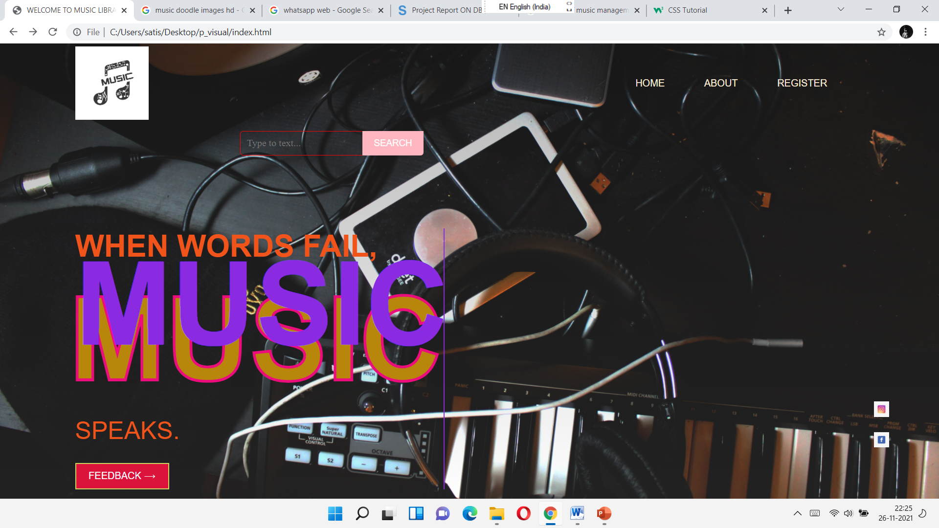

**SOURCE CODE OF HOME PAGE**

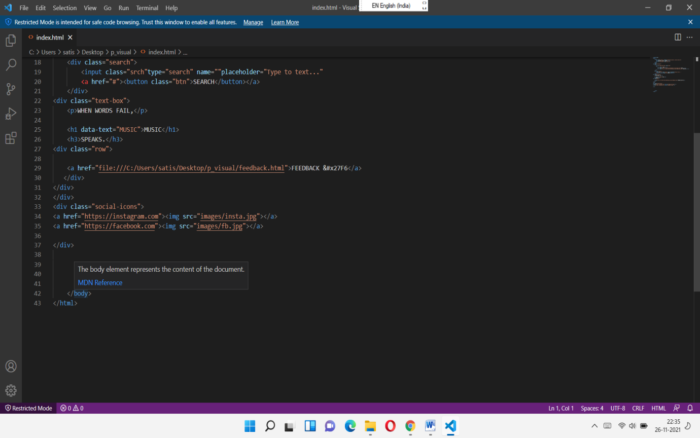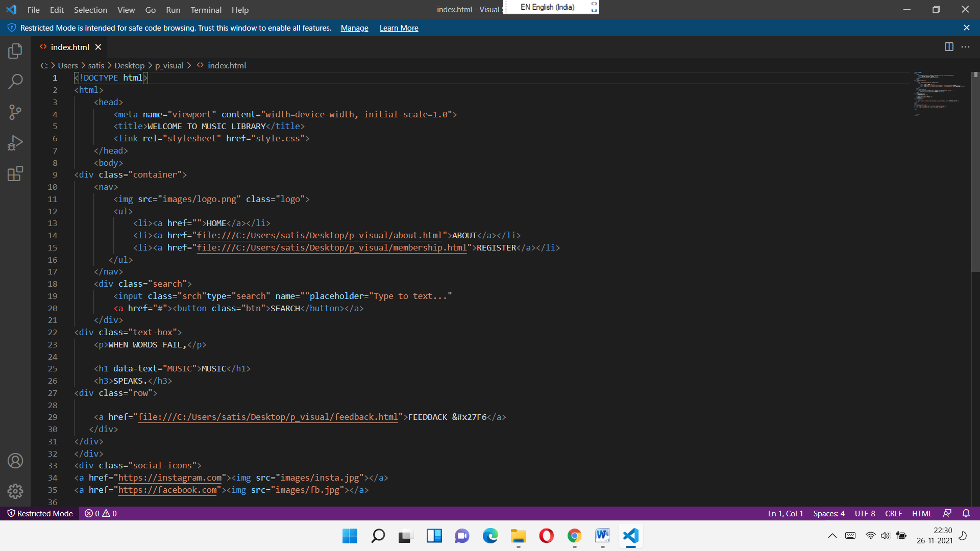

**CSS CODE OF ABOUT PAGE**

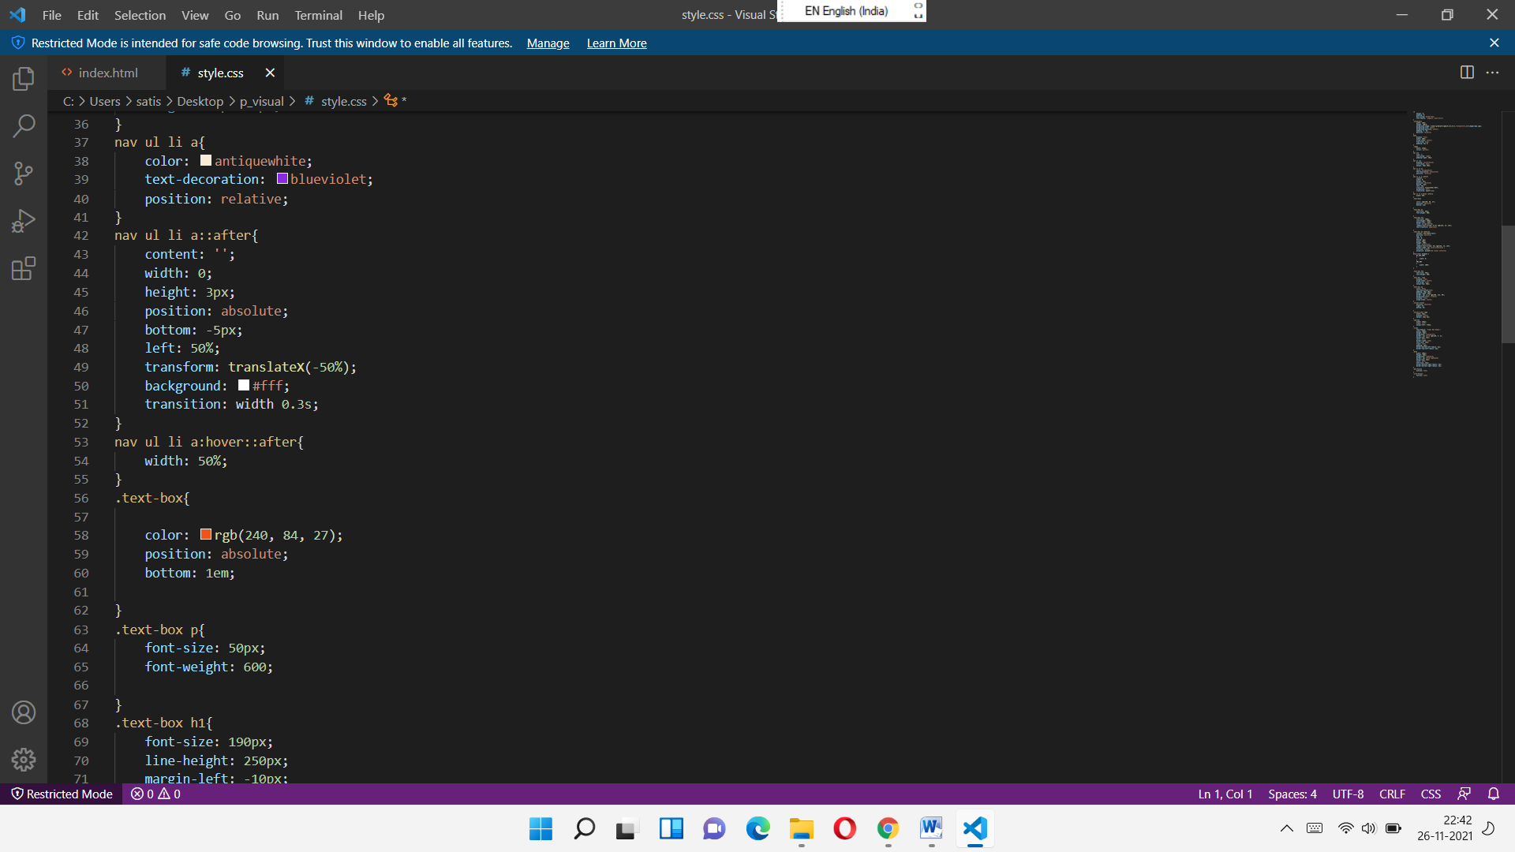

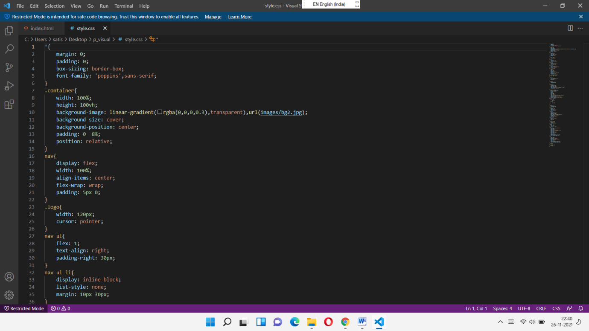

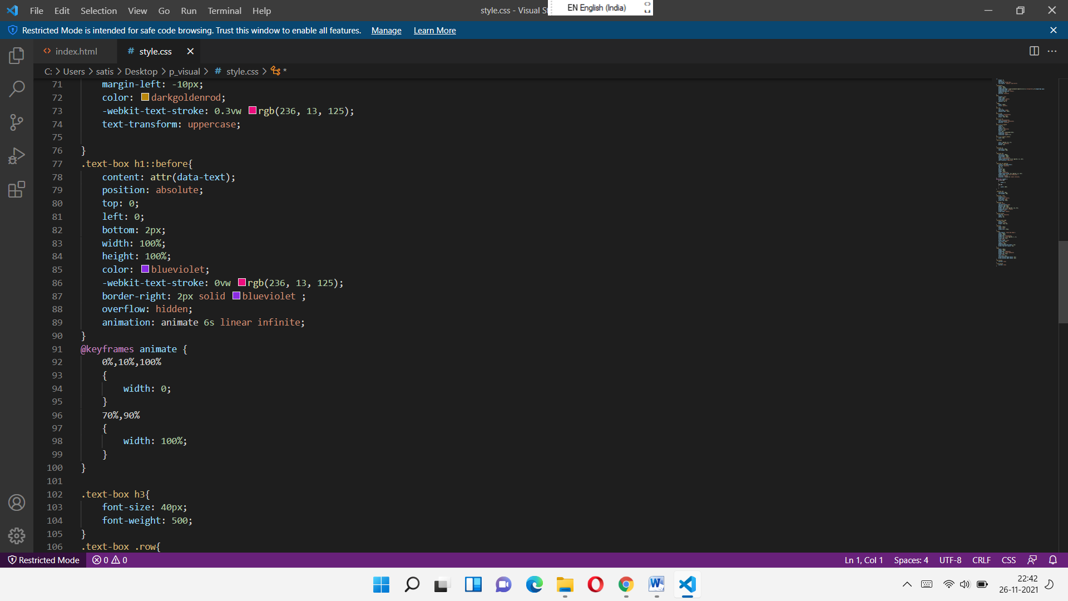 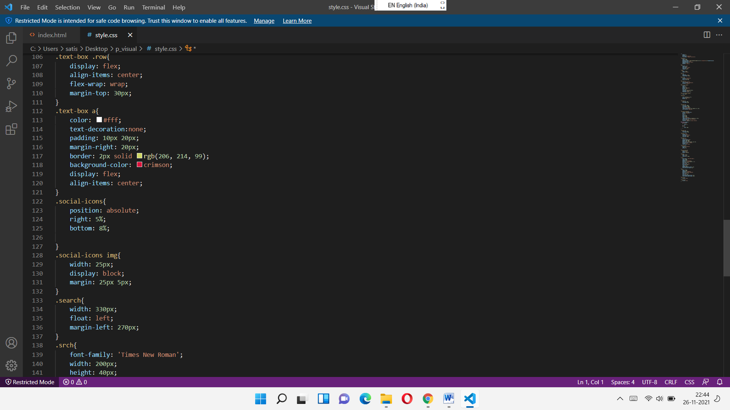

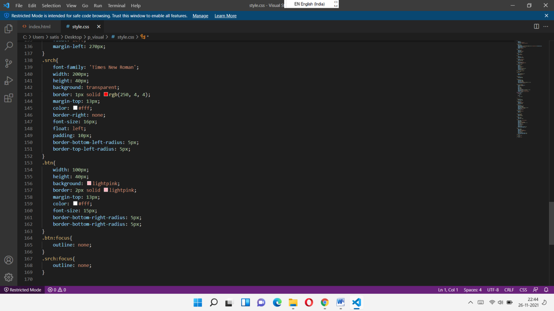

**ABOUT PAGE**

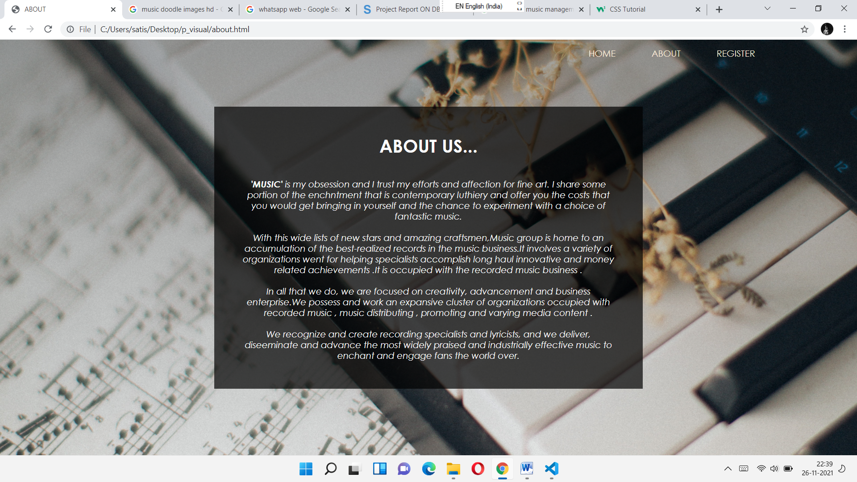

**SOURCE CODE OF ABOUT PAGE**

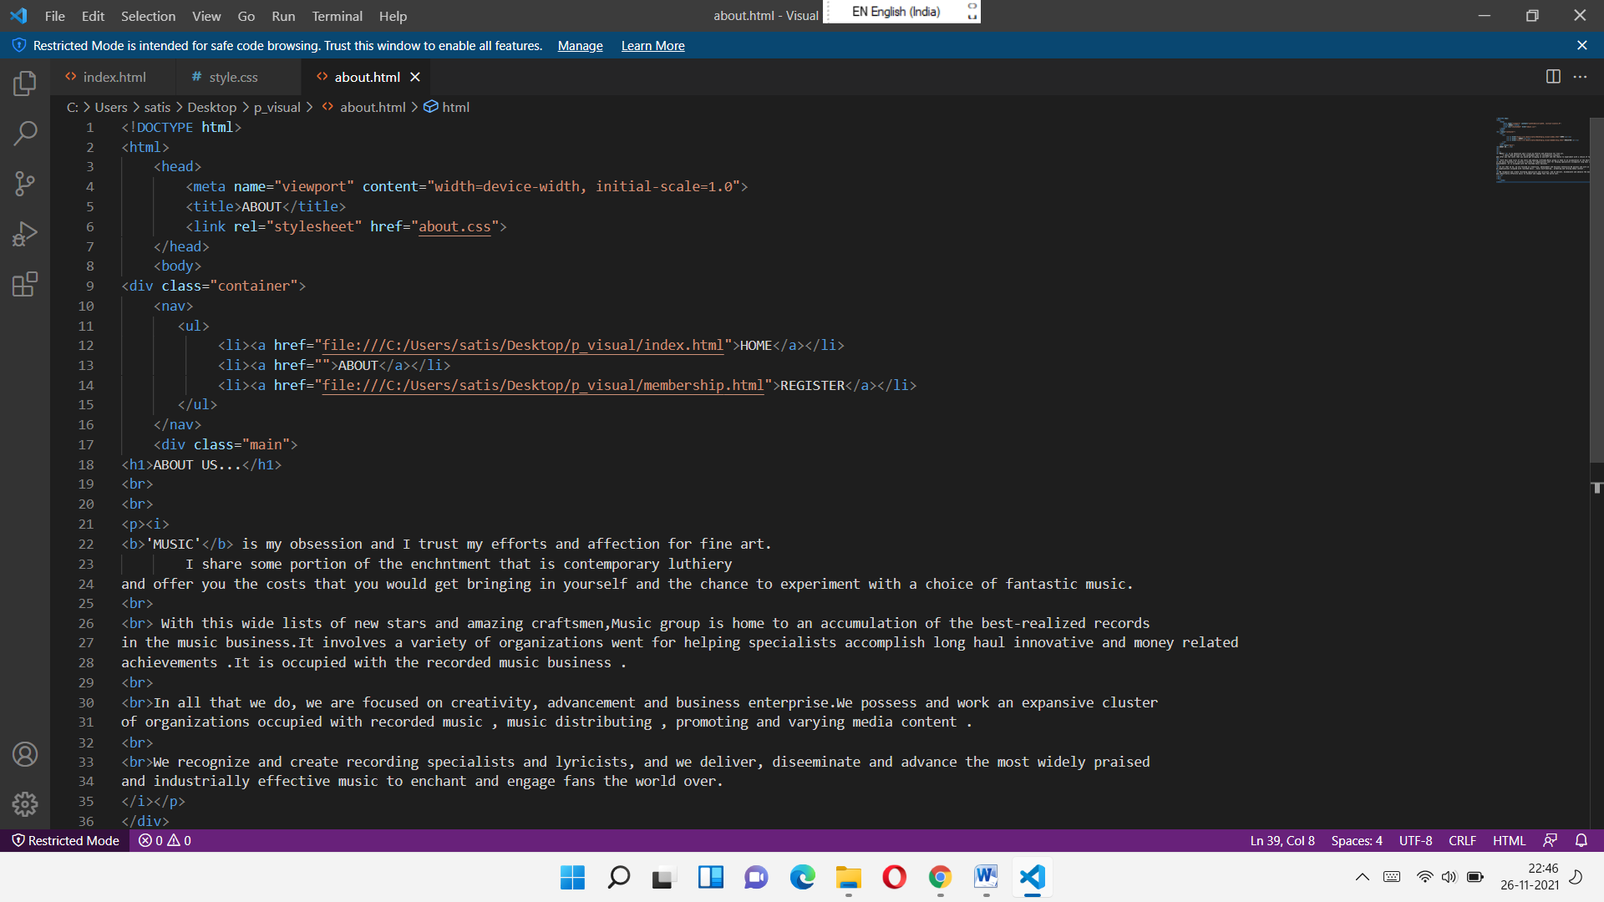

**CSS CODE OF ABOUT PAGE**

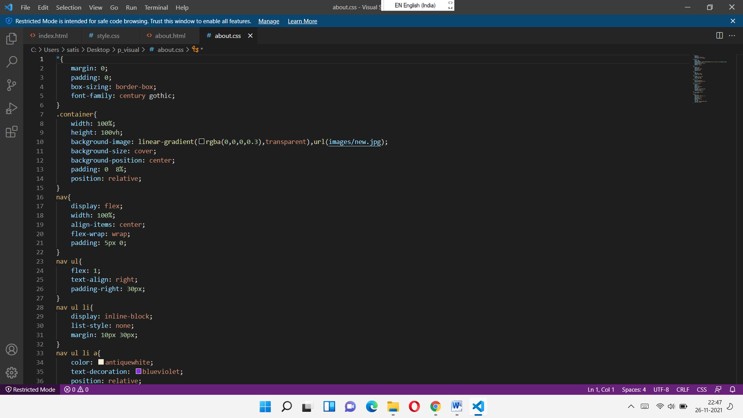 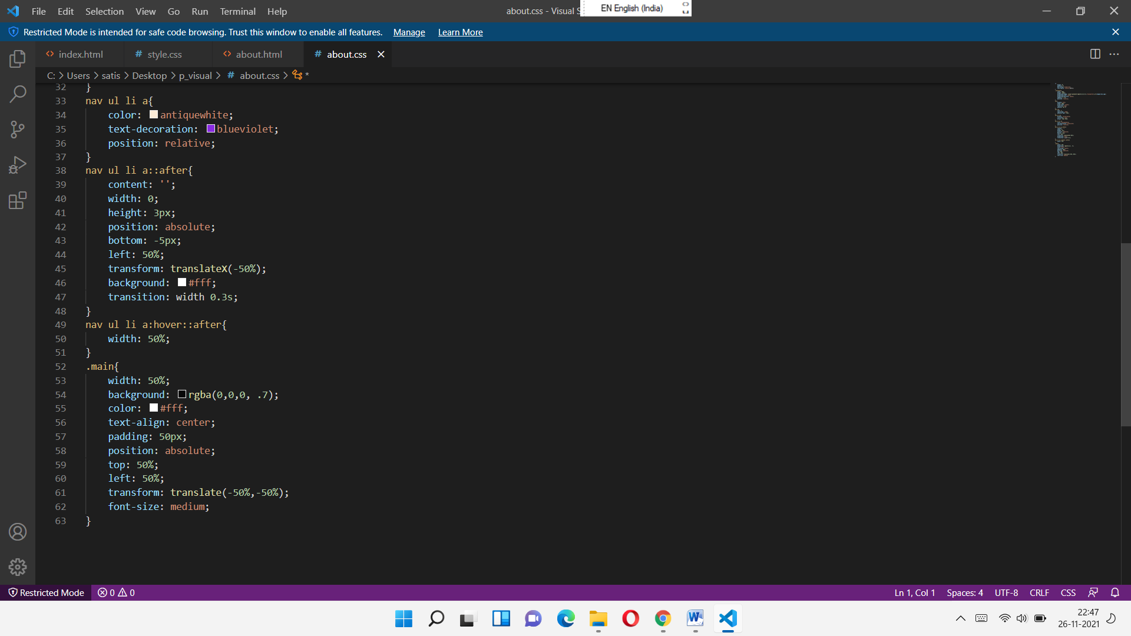

**REGISTRATION PAGE**

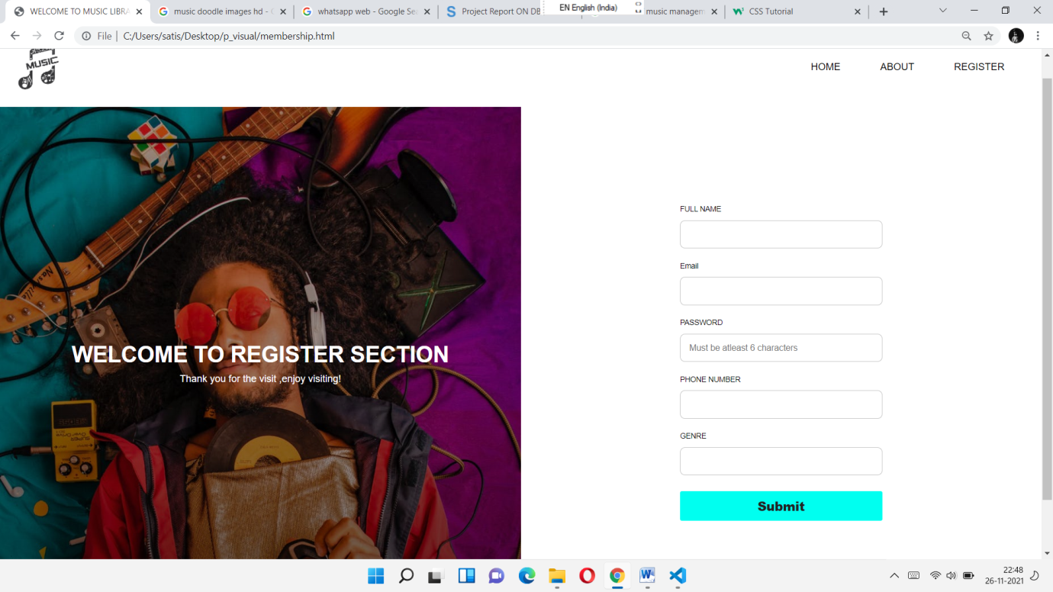

**SOURCE CODE OF REGISTRATION PAGE**

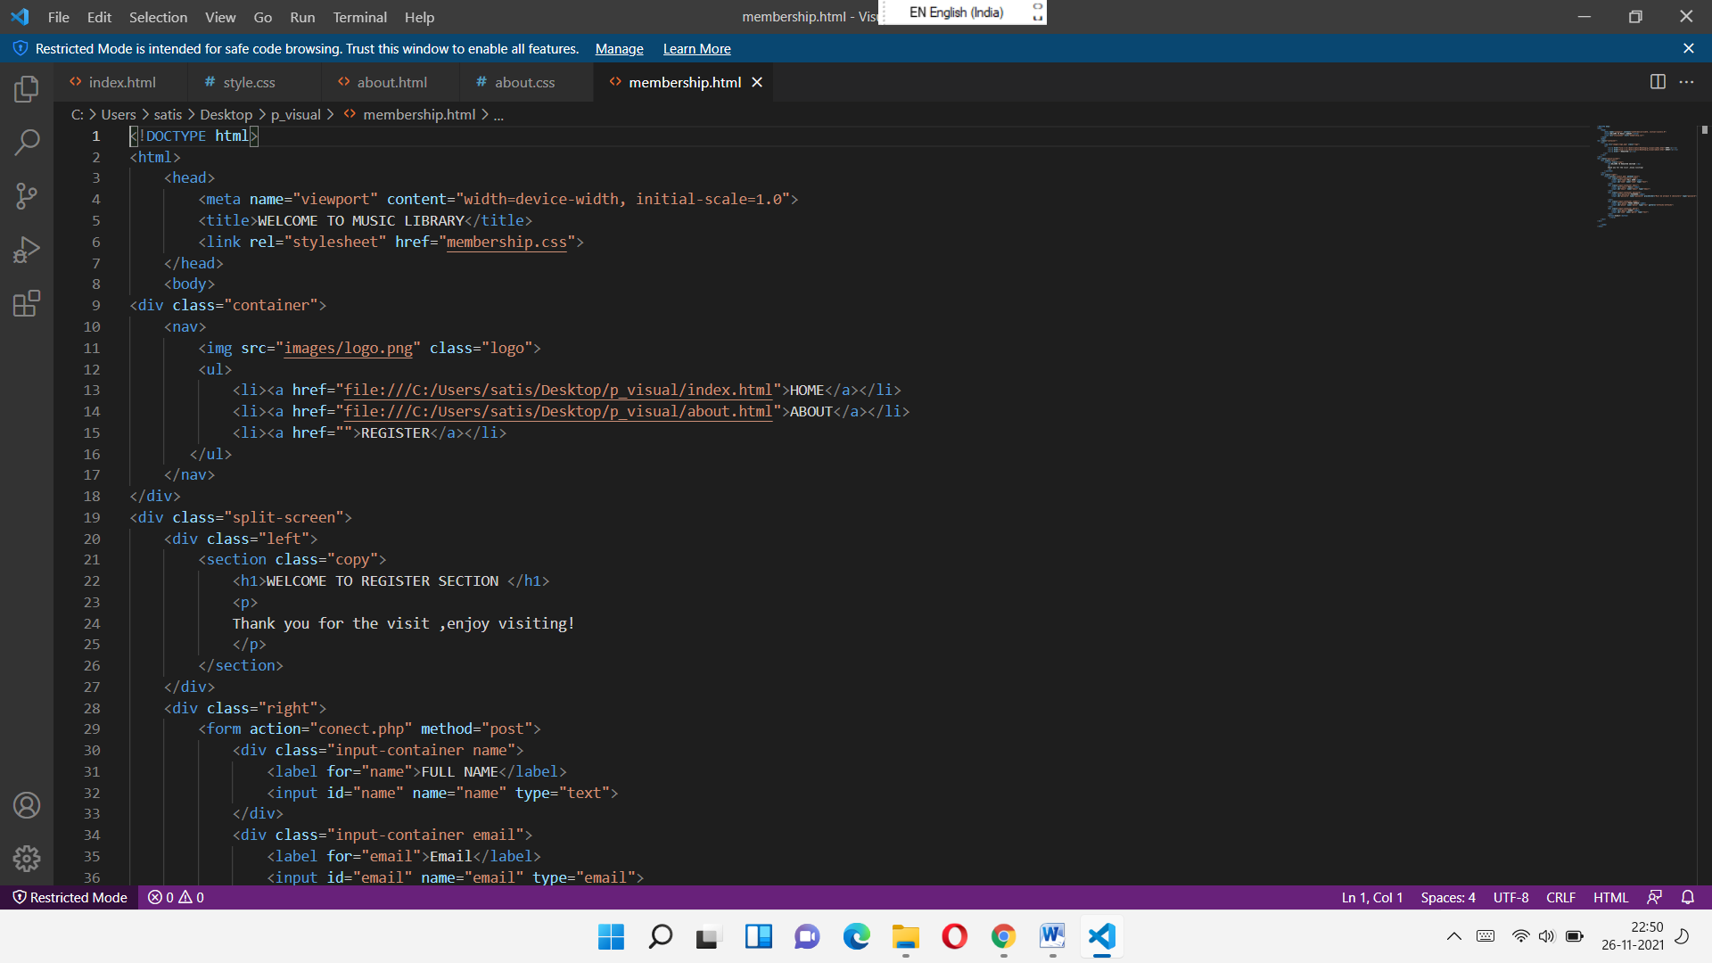 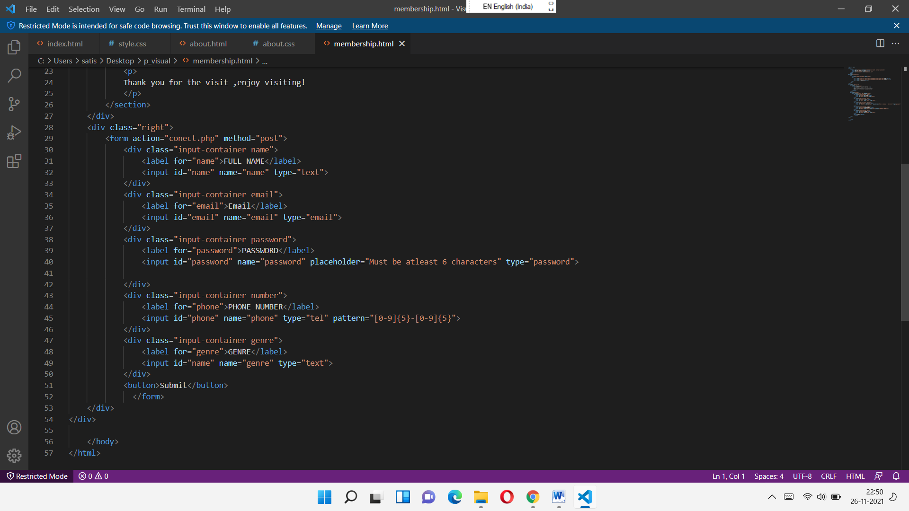

**CSS CODE OF REGISTRATION PAGE**

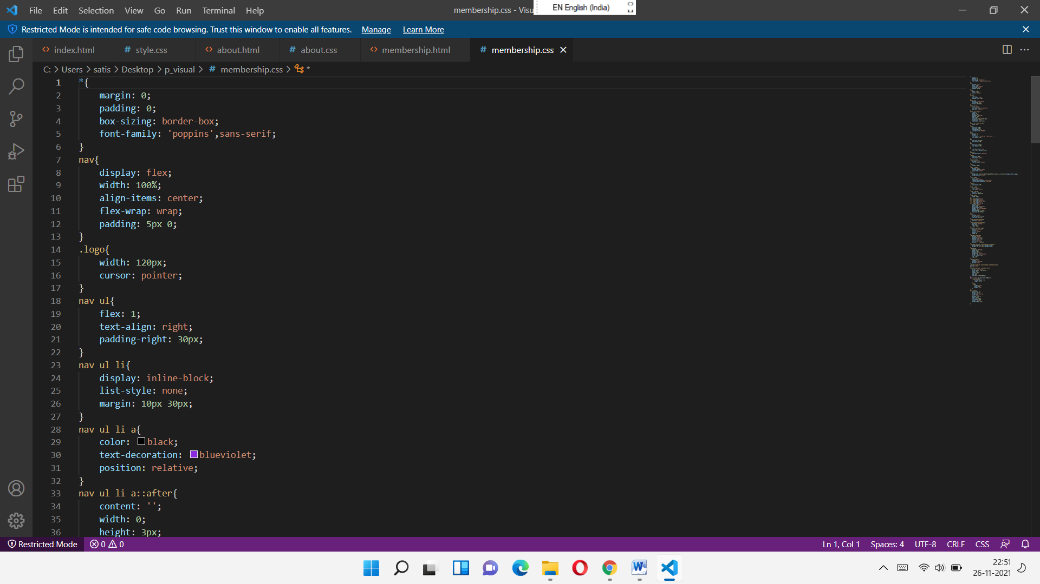 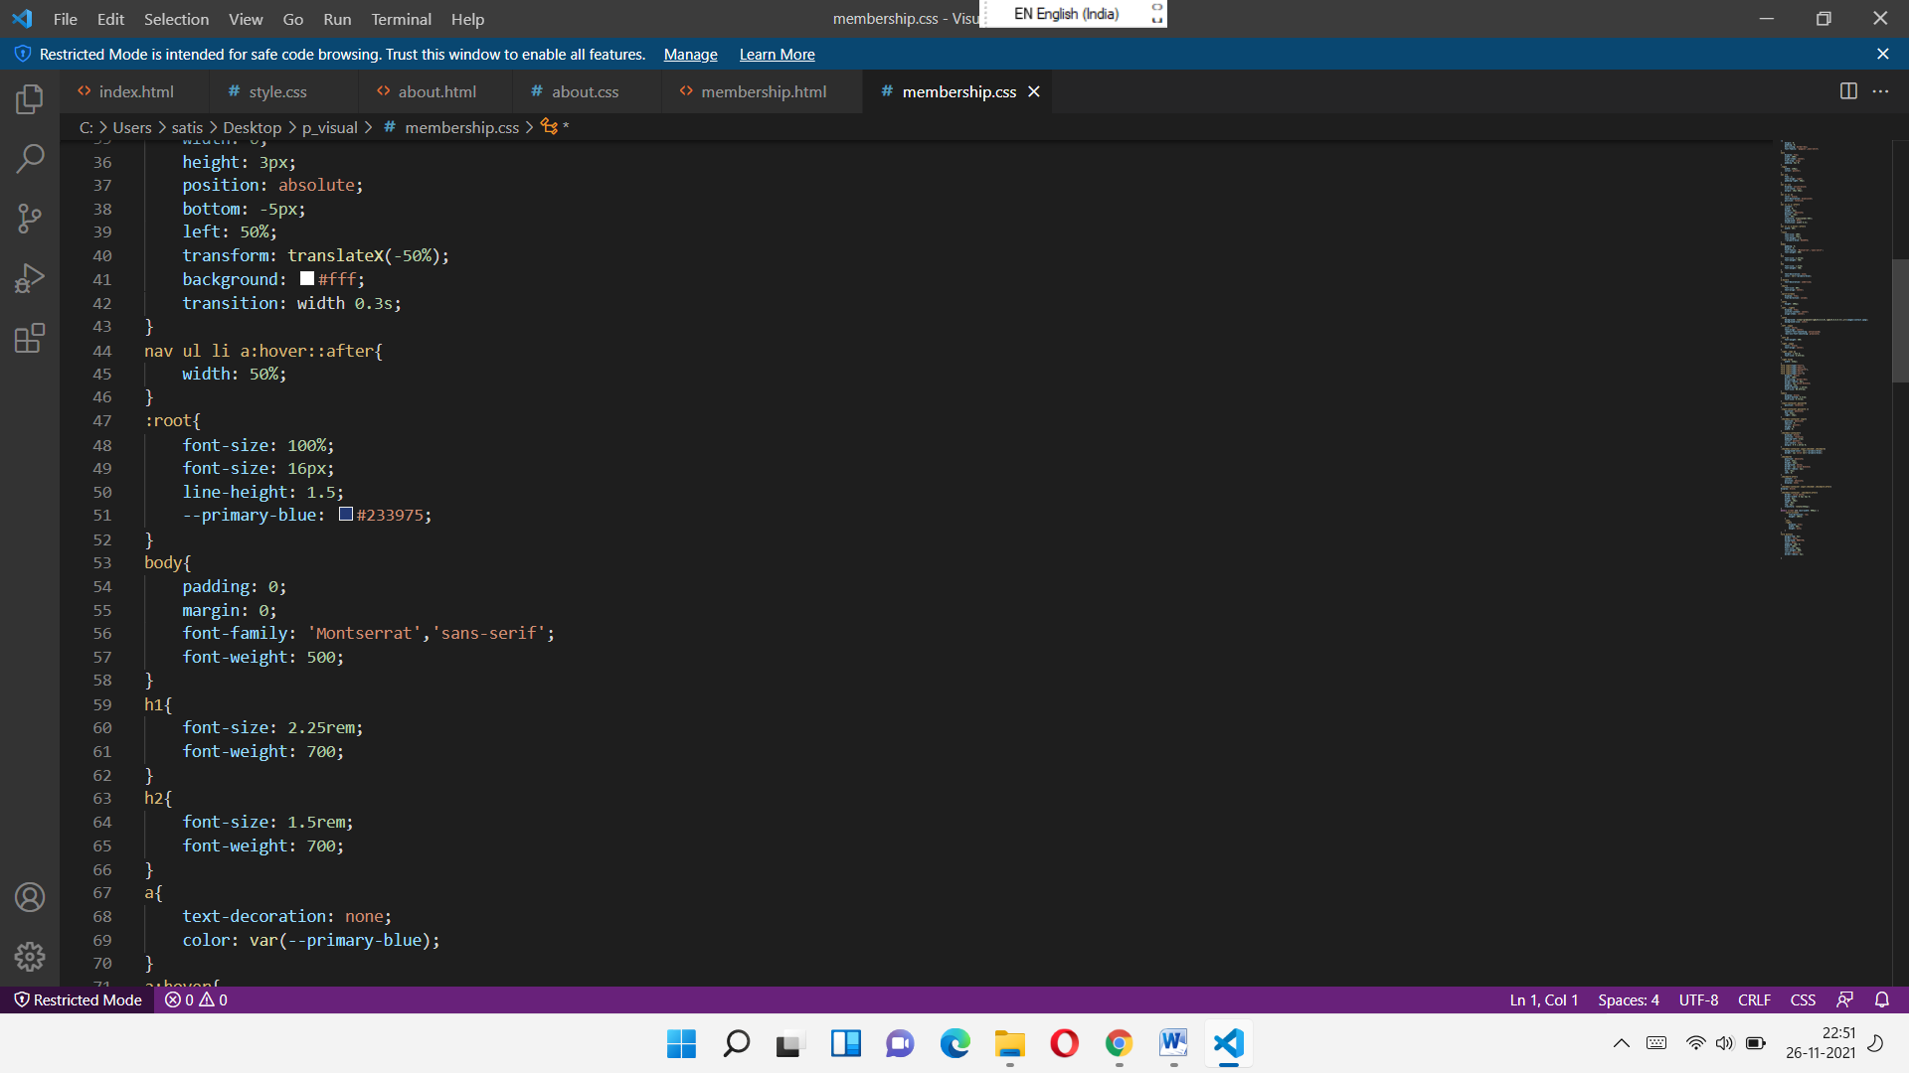

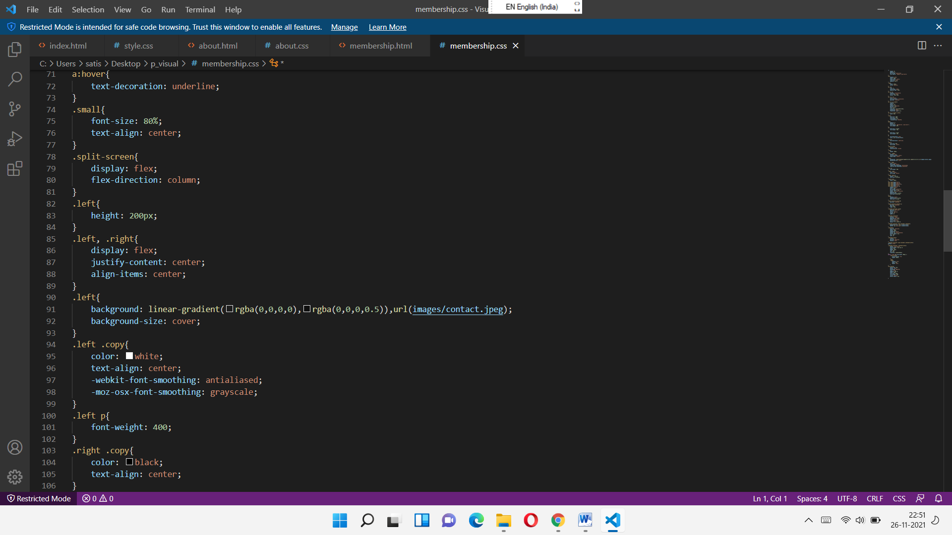 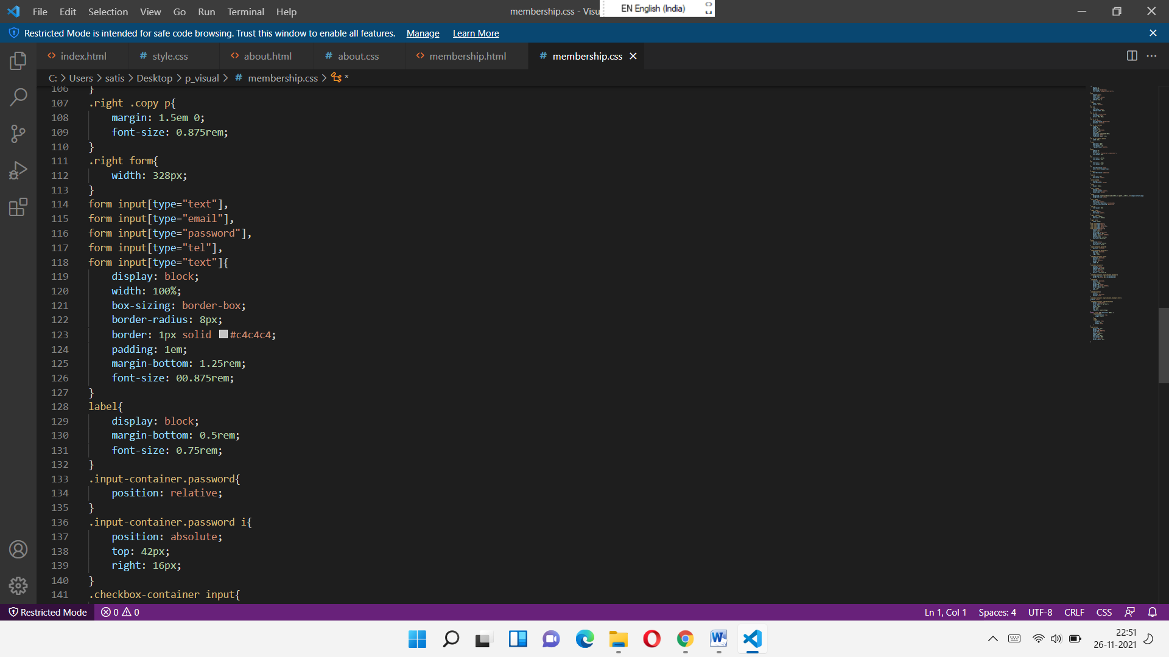

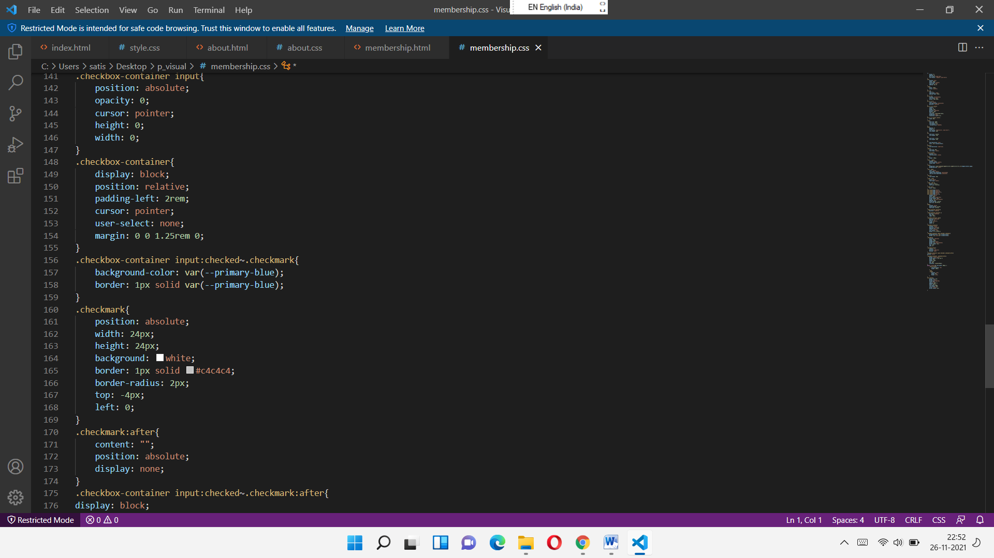 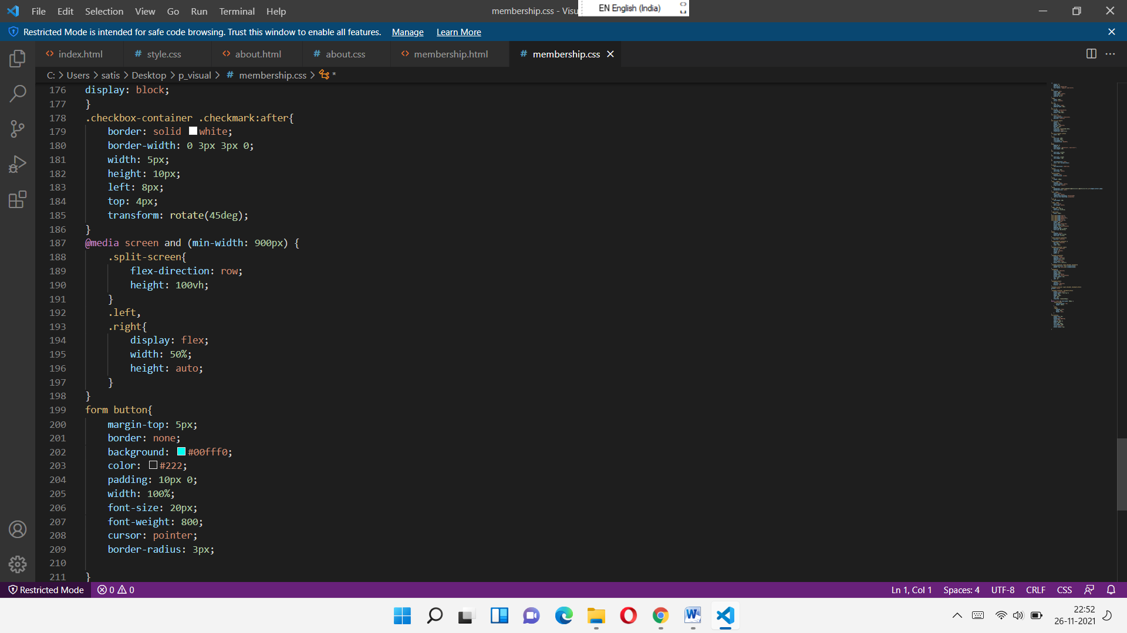

**FEEDBACK PAGE**

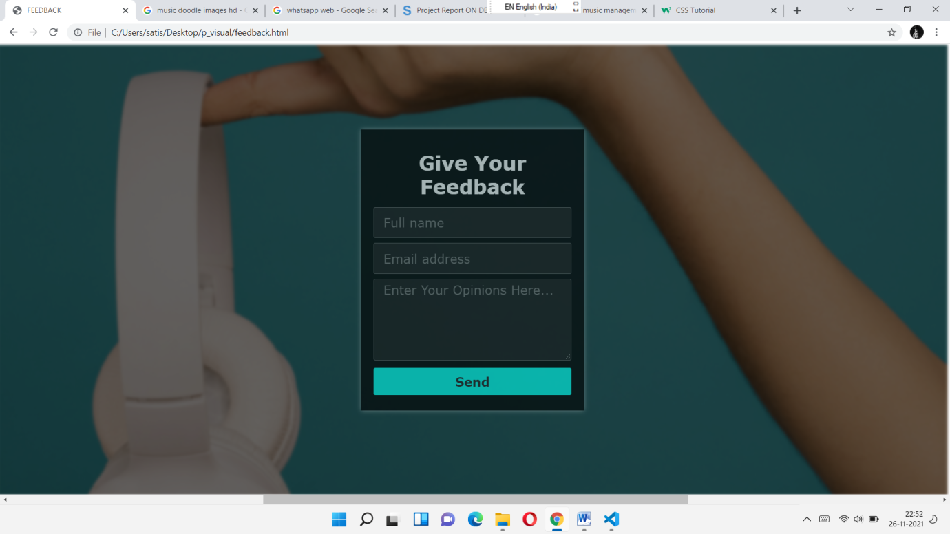

**HTML CODE OF FEEDBACK PAGE**

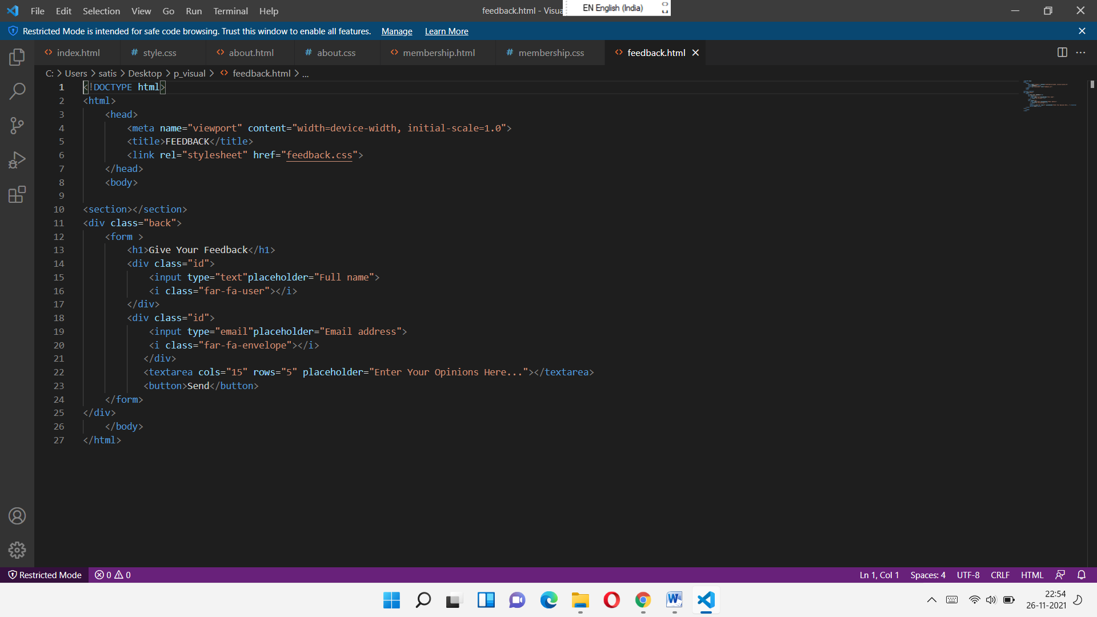

**CSS CODE OF FEEDBACK PAGE**

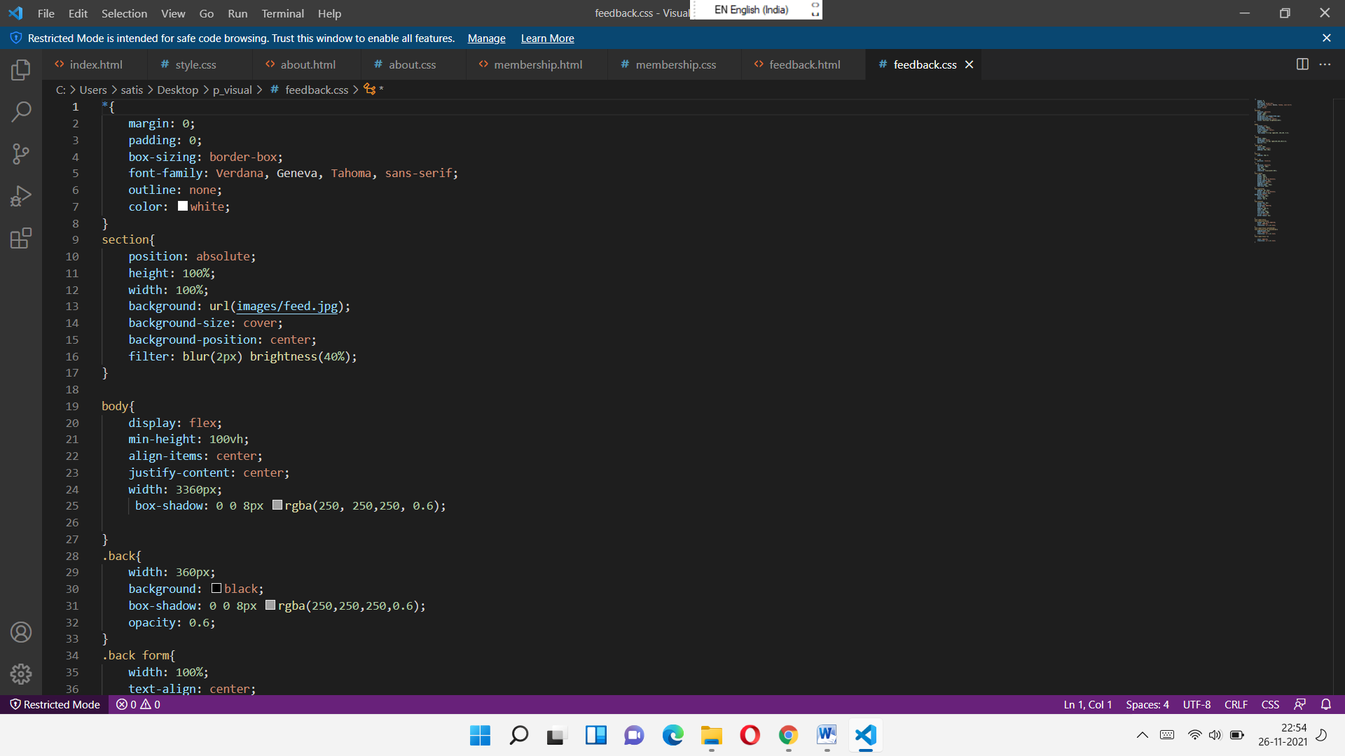

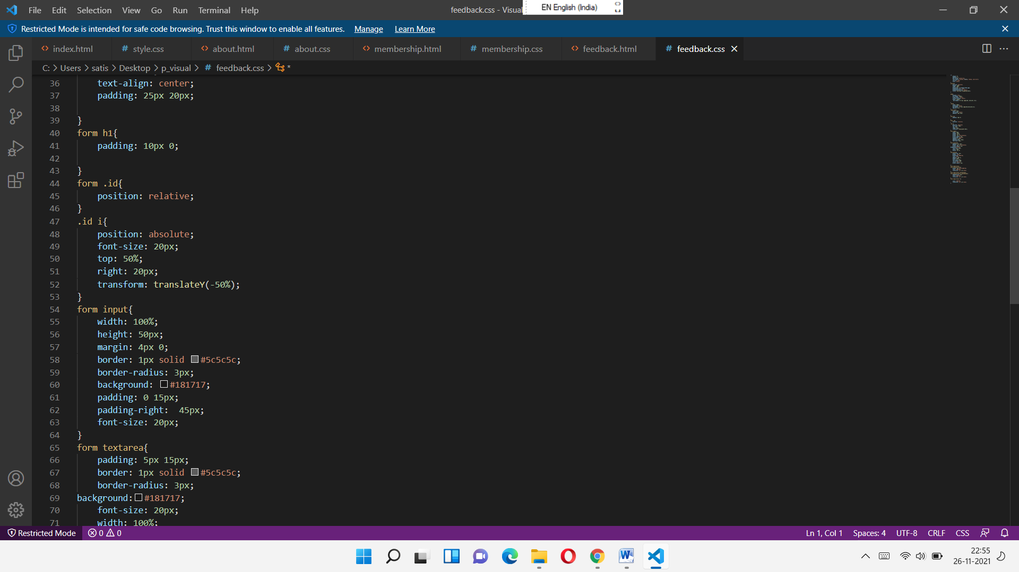 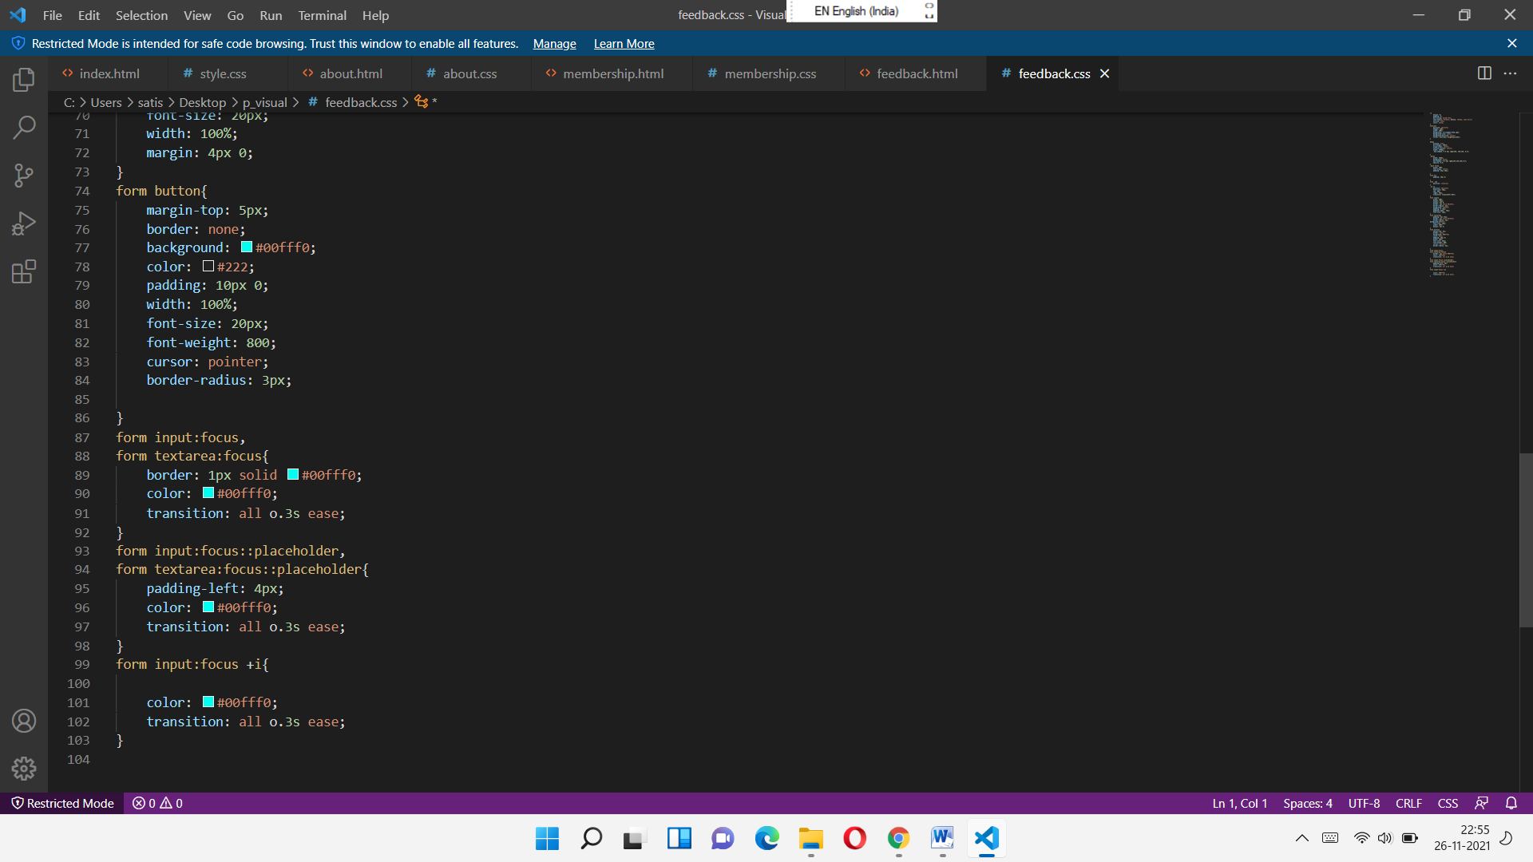

**CONCLUSION**

* The project MUSIC MANAGEMENT is for computerizing all the data and information related to music for music lovers.
* The software takes care of all the requirements and is capable to provide easy and effective storage of information to users.
* In this project we have created one application which is easy to access and user friendly.The application keeps a backup of the music management data which includes their details.